Little SPARK: Simple Play Adaptations to Reference for Kids

TalkingBrix 2
Description: | Image:
TalkingBrix 2 is a set of three single message, Augmentative and Alternative Communication (AAC) devices that supports those with speech challenges. The devices are lightweight and can easily mounted to a variety of surfaces. A clear snap on cover protects a picture that may be selected to represent the communication message used on the device.  Purchasing Information  Quick Start Guide | 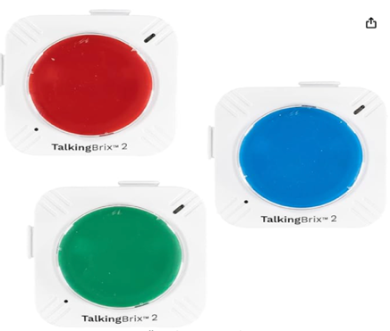

Who Might Benefit?
Those who struggle with understanding spoken instructions, communicating verbally, following multi-step tasks, and have the fine motor ability to press a button.
Why Use?
Provides an opportunity to make choices, comment to others, and hear verbal directions paired with a visual cue to support schedules, routines, and various activities throughout the day.
Instructions for Use: | Adaptation Ideas:
Environmental Considerations  - Use in any environment and take it on the go.  Positioning  - Use in any position and on most surfaces.  Basic Play/Use  - Record the message and press the switch top to activate the message.  Extended Play/Use  - Provide instructions, make requests, share information, communicate bathroom needs, use as labels for classroom centers/areas.  Play/Use with Others  - Make games interactives (Simon Says), add communication to toys/appliances, repeat phrases during story time.  - Send a message to others. | Stabilize It  - Use Dycem under the item or attach Velcro.  Add Sensory Cues  - Add sensory cues to the activation button such as puffy stickers, puffy paints, different textures, or change the button color.  Communication Support  - Vocabulary words would depend on the activity.  Alternative Uses  - Link together or Velcro to foam board to provide choices, visual/auditory sequence/steps, provide first/then support, or construct simple sentences/phrases.
Words to Encourage Play/Use
Push  | Listen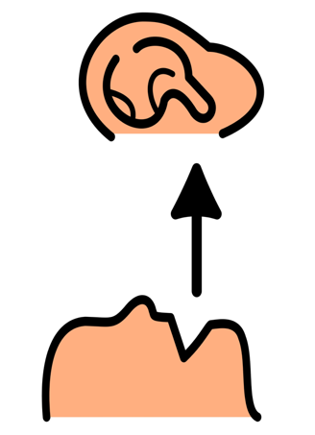 | All Done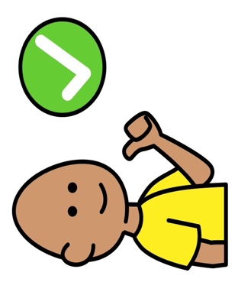
My Turn | Your Turn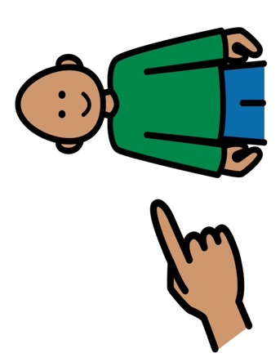 | More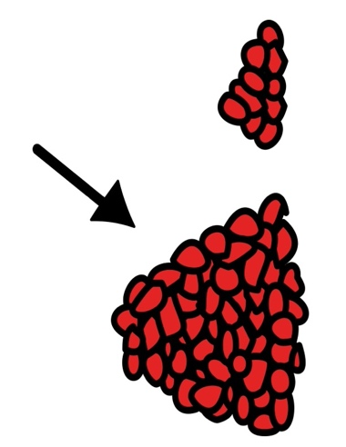
Wait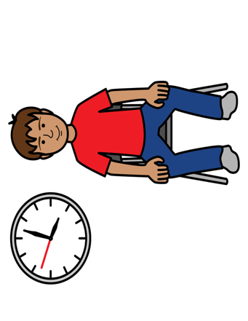 | Stop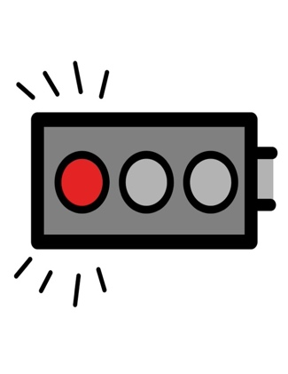 | Go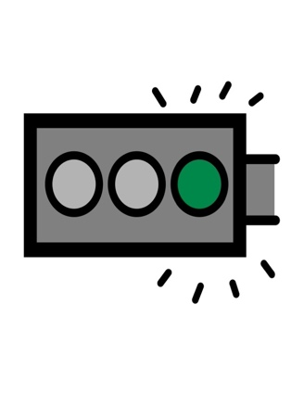
*”Adaptations” adapted from: Haugen’s Modes for Adapting Toys based on materials from the "Let's Play" Project at the University of Buffalo
PCS is a trademark of Tobii Dynavox, LLC. All rights reserved. Used with permission.

